Northborough Youth Soccer (NYSA) Scholarship 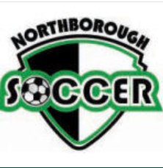

Last Name First Middle Initial

Street City Zip Code

Your Cell Number Your Email Address

Have you applied to college (Y/N) _________

If you have already decided which college you will be attending, please list that college here:

List academic honors, awards, and leadership roles while in high school:

Please use a separate document to describe:

- Your specific activities, roles, participation and length of time involved with NYSA.
- How has your participation in NYSA/Soccer helped you develop into the person you are today.
- Other information you feel would highlight your life experiences.

List your work experience:

Employer Dates of Employment Hours/Week

* ** * * * *
RETURN APPLICATION AND RELATED MATERIALS TO CRC or NYSA PO Box 141, Northboro, MA 01532 by March 3, 2024.
LATE APPLICATIONS WILL NOT BE ACCEPTED.

Updated 1/2024

